**API DOCUMENTATION FOR JIJI E-COMMERCE WEBSITE**

**Base URL:**

* <https://jijiapi-2n80.onrender.com/api/products>

**Consumes:**

application/json

1. **Operation**
2. Get all available products

**Request type:** GET

**Endpoint**:

* /products/

**Description**:

Fetches all products and provides functionality to optionally filter by category, region and price range.

**Request Parameters for search**:

* category (optional): Category ID to filter products by category.
* region (optional): Region ID to filter products by region.
* minPrice (optional): Minimum price to filter products.
* maxPrice (optional): Maximum price to filter products.

**Response: 200 OK: Returns a list of products.**

1. **Operation**
2. Get a particular product by Id

**Request type:** GET

**Endpoint**:

* /products/{id}/

**Description**:

Fetches a product based on the product id

**Request Parameters**:

* Valid product Id

**Response:**

1. **200 OK: Returns a list of products.**
2. **404 Not found : Product does not exist**

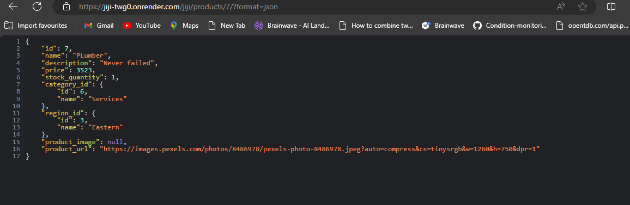

**2.**

**a. Operation:**

Get all products added to cart

**Request type:** GET

**Endpoint**:

* /carts/

**Description**:

Fetches all products that have been added to cart.

**Request Parameters for search**:

* No request parameter

**Response: 200 OK: Returns a list of all products in cart**

**3.**

**a. Operation:**

Add a product to cart

**Request type:** POST

**Endpoint**:

* /carts/

**Description**:

Add A product to cart.

**Request Parameters for search**:

* No request parameter

**Response: 200 OK: Returns a list of all products in cart**

**Request Body:**

**Response:**

* **201 Created**: Product added to cart successfully

**403 Forbidden: Product was not added to cart**

**404 Not Found**: Product not found

**4.**

**a. Operation:**

Update the quantity of a product added to the cart

**Request type:** PATCH

**Endpoint**:

* /carts/{Id}/

**Description**:

It alters only the quantity of a product added to the cart using the Id

**Request Parameters**:

* Pass Id of product

**Request Body:**

**Response: 200 OK: Returns a list of all products in cart**

**b. Operation:**

Delete a product added to the cart

**Request type:** DELETE

**Endpoint**:

* /carts/{Id}/

**Description**:

It alters only the quantity of a product added to the cart using the Id

**Request Parameters**:

* Pass Id of product
* **Response:**

**204 No Content : Product has been removed from cart**

**404 Not Found: Selected item does not exist in cart**

**5.**

**Operation:**

Get the stock quantity of a particular product

**Request type:** GET

**Endpoint**:

* /quantity/{Id}/

**Description**:

It displays only the quantity of a product added to the cart using the Id

**Request Parameters**:

* Pass Id of product



* **Response:**

**200 OK: Displays the stock quantity of the selected product**

**Notes**

* Ensure that appropriate headers such as Content-Type: application/json are set for the requests.
* All endpoints expect the data in JSON format for both request bodies and responses.
* Ensure max price is higher than min price

**Example Usage**

**Fetch All Products with Filters**

* /products?category=1&region=4&minPrice=50&maxPrice=200